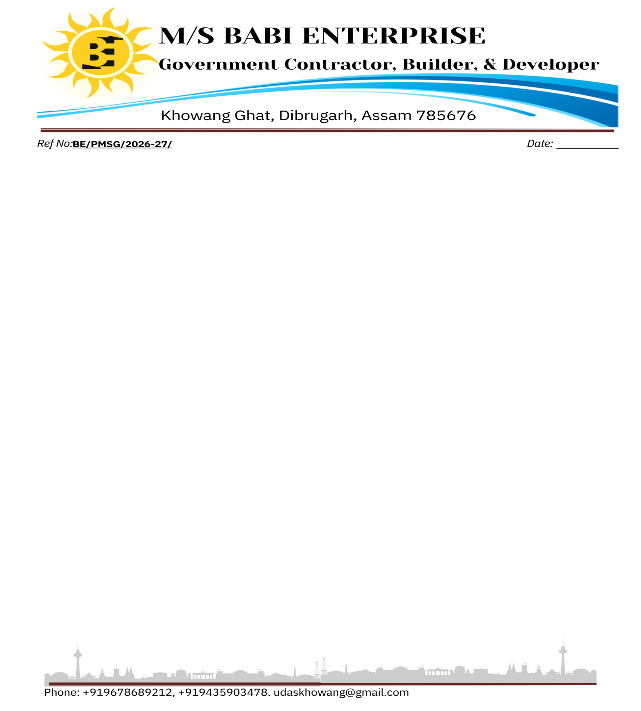

Ref No: {{REF_NO}} Date: {{DATE}}

To,

Consumer Name: {{CUSTOMER_NAME}}
APDCL Consumer No: {{CONSUMER_NO}}
Address: {{ADDRESS}}
Phone No: {{PHONE}}
System Phase: {{PHASE_TYPE}}

Sub: Quotation for {{SYSTEM_CAPACITY}}, Rooftop DCR On-grid Solar Power Plant.

Dear Sir,
Thank you for your kind interest in the installation of a Renewable Energy – PM Surya Ghar Muft Bijli Yojana (On-Grid) Solar Power System at your premises. We truly appreciate your initiative in adopting green, clean energy and contributing towards the reduction of carbon footprint. We are grateful for the opportunity to be associated with you and are pleased to submit our commercial proposal for the supply, installation, and commissioning of a {{SYSTEM_CAPACITY}} {{PHASE_TYPE}} On-Grid Solar Power System.
Our Offer for {{SYSTEM_CAPACITY}} {{PHASE_TYPE}} On-Grid Solar Power System supply, installation, and commissioning (DCR Compliant).
Sl. No. | Description of Items | Technical Specification | Qty | Rate per Unit (₹) | Amount (₹)
1 | Design, supply, installation, testing and commissioning of rooftop solar on-grid system with BiFacial DCR PV modules and Inverter of TATA SOLAR/WAAREE MAKE. | {{SYSTEM_CAPACITY}}  {{PHASE_TYPE}} | 1 | {{TOTAL_AMOUNT}} | {{TOTAL_AMOUNT}}
Amount in words: {{AMOUNT_IN_WORDS}}
Bank AC Details | BABI ENTERPRISE  CA NO. 30631194096, IFSC-SBIN00014789
Warranty | 25 Years On Solar Panels (Performance) Warranty
Warranty | 8 Years On Inverter
Taxes | Our price is inclusive of GST 5%.

Thank you for considering our quotation. We look forward to the opportunity to serve you.
